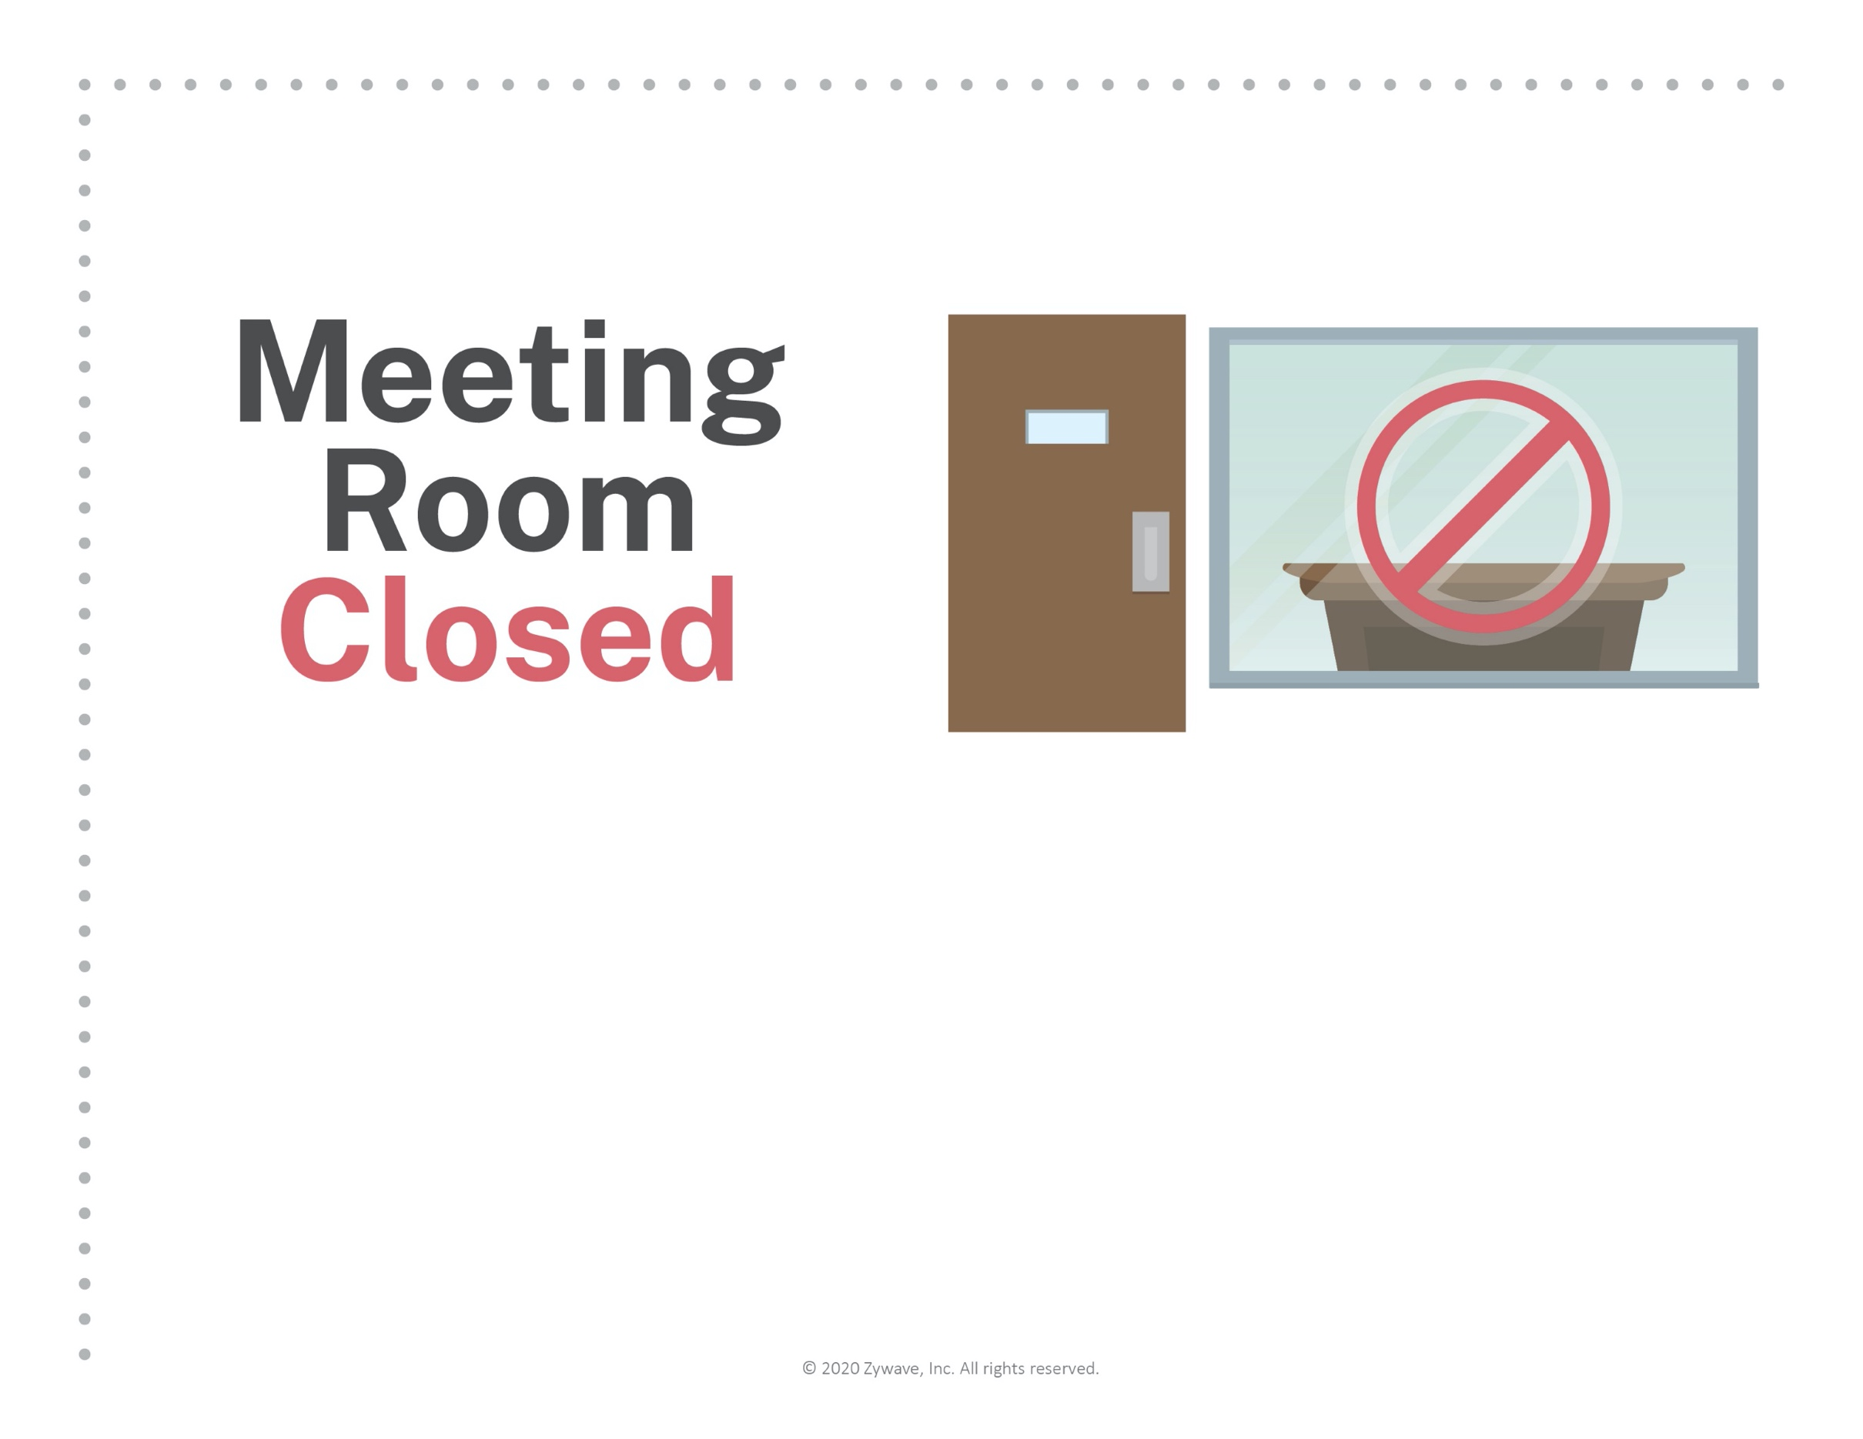
To ensure a safe and sanitary workplace,
this meeting room has been temporarily closed.
Thank you for your understanding.

