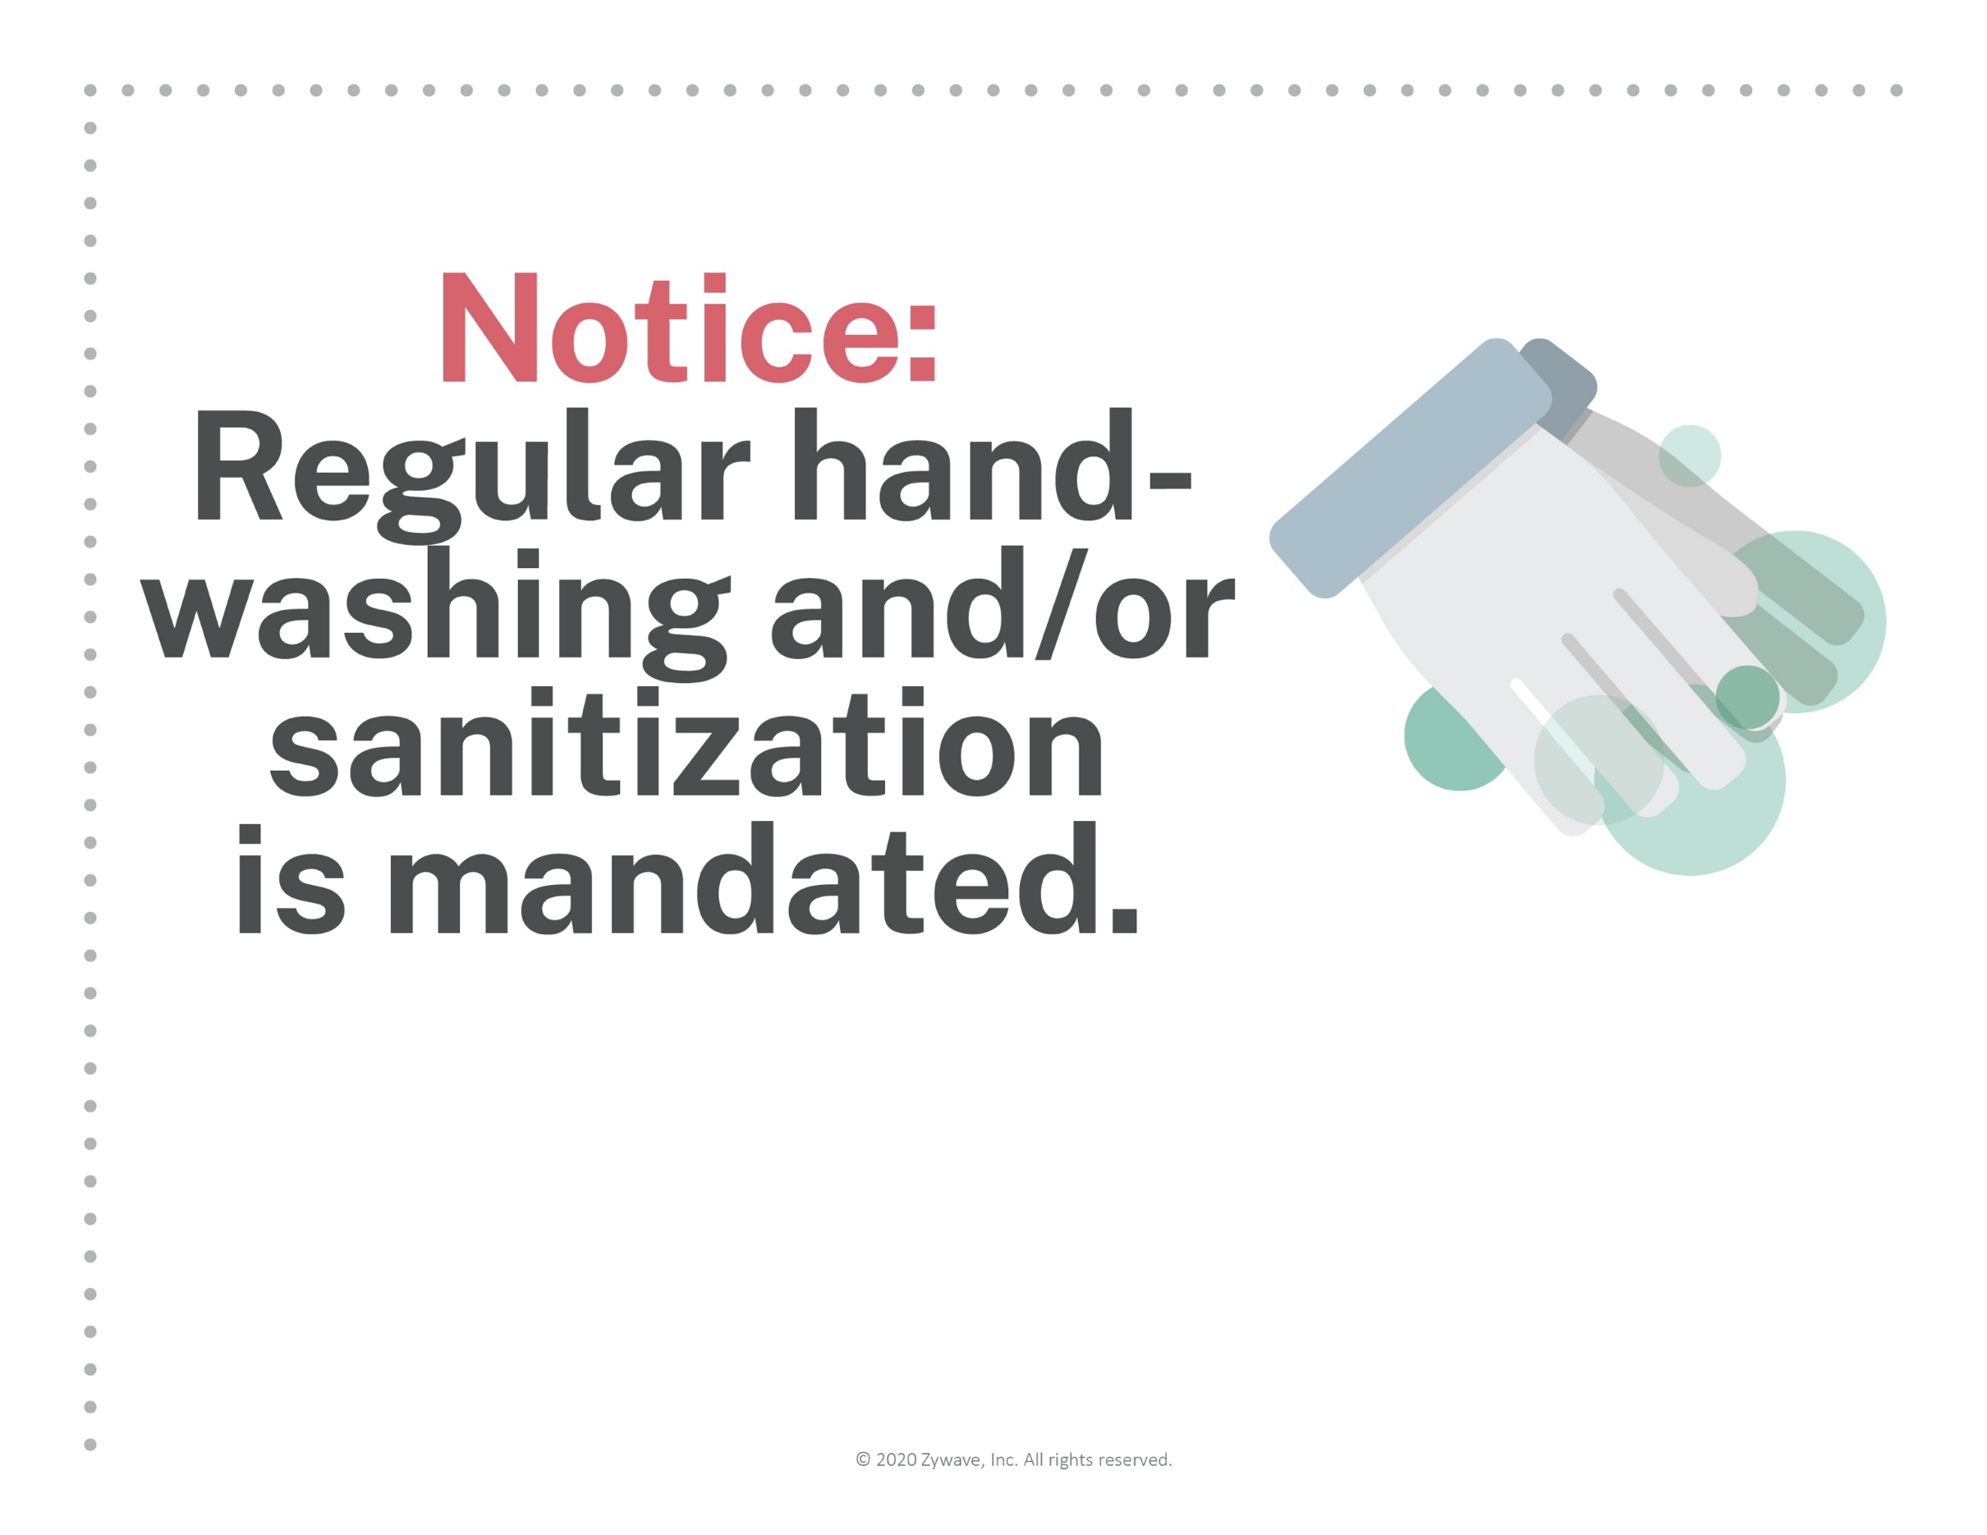
Please use soap and water or hand sanitizer
to help keep our workplace safe and clean.

