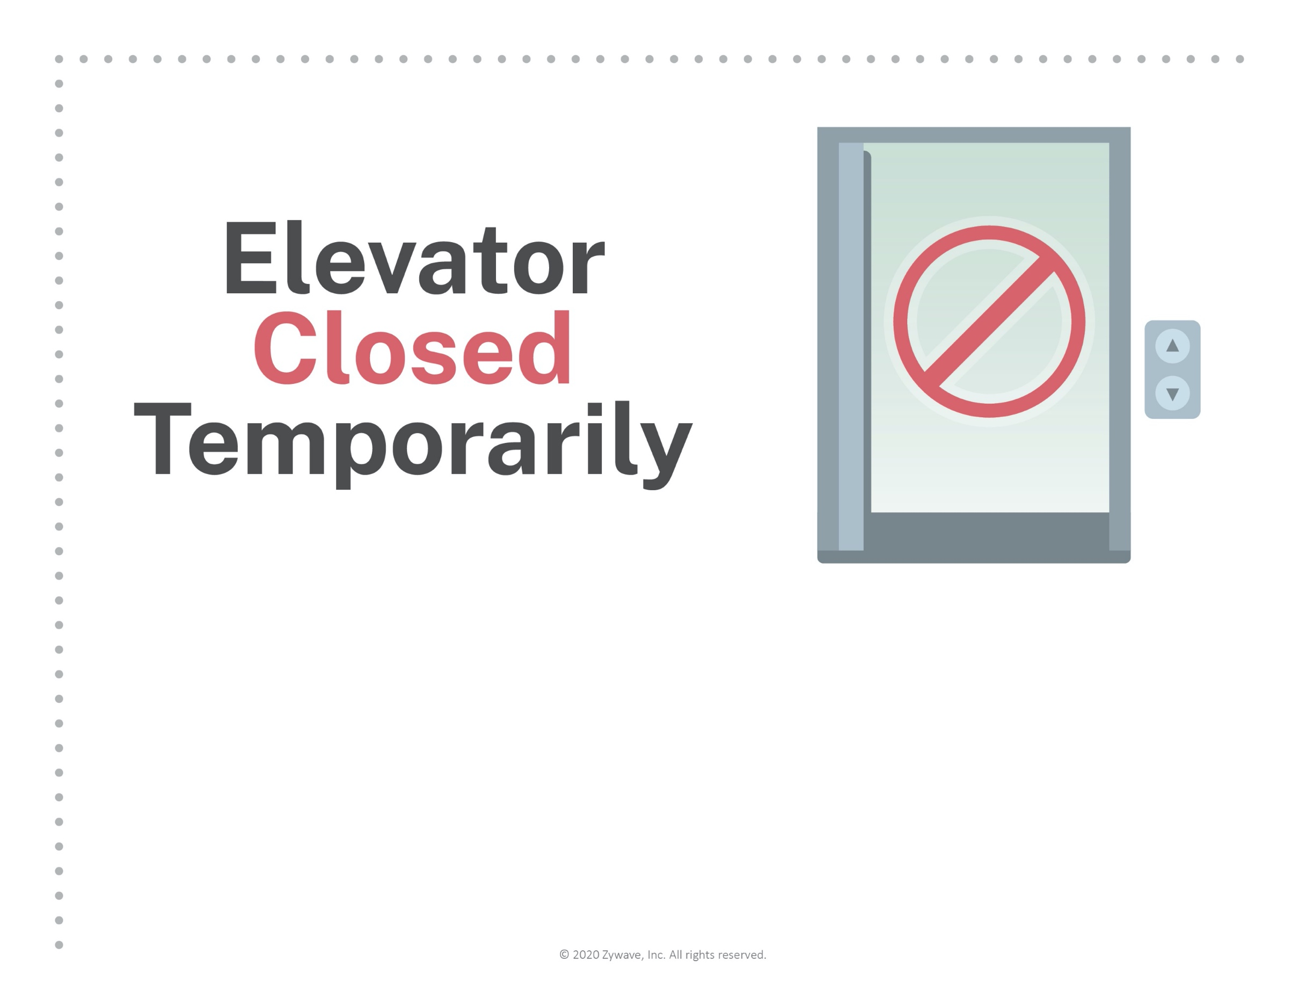
To ensure a safe and sanitary workplace,
the elevator will be unavailable until
further notice.
We apologize for any convenience and
thank you for your flexibility.

