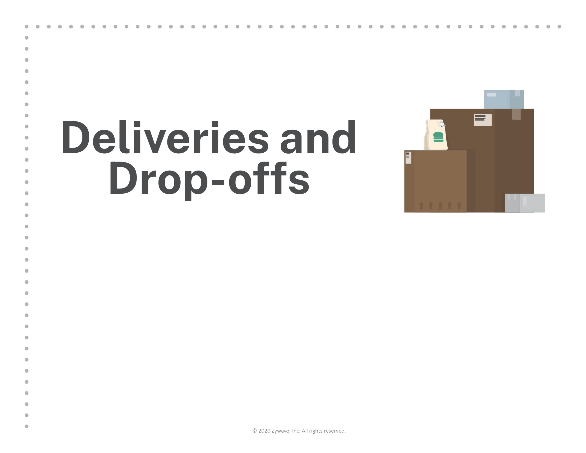
To facilitate safety of our employees through social
distancing, please leave all deliveries and drop-offs for
[Company Name] in this area.
Thank you for your cooperation.

