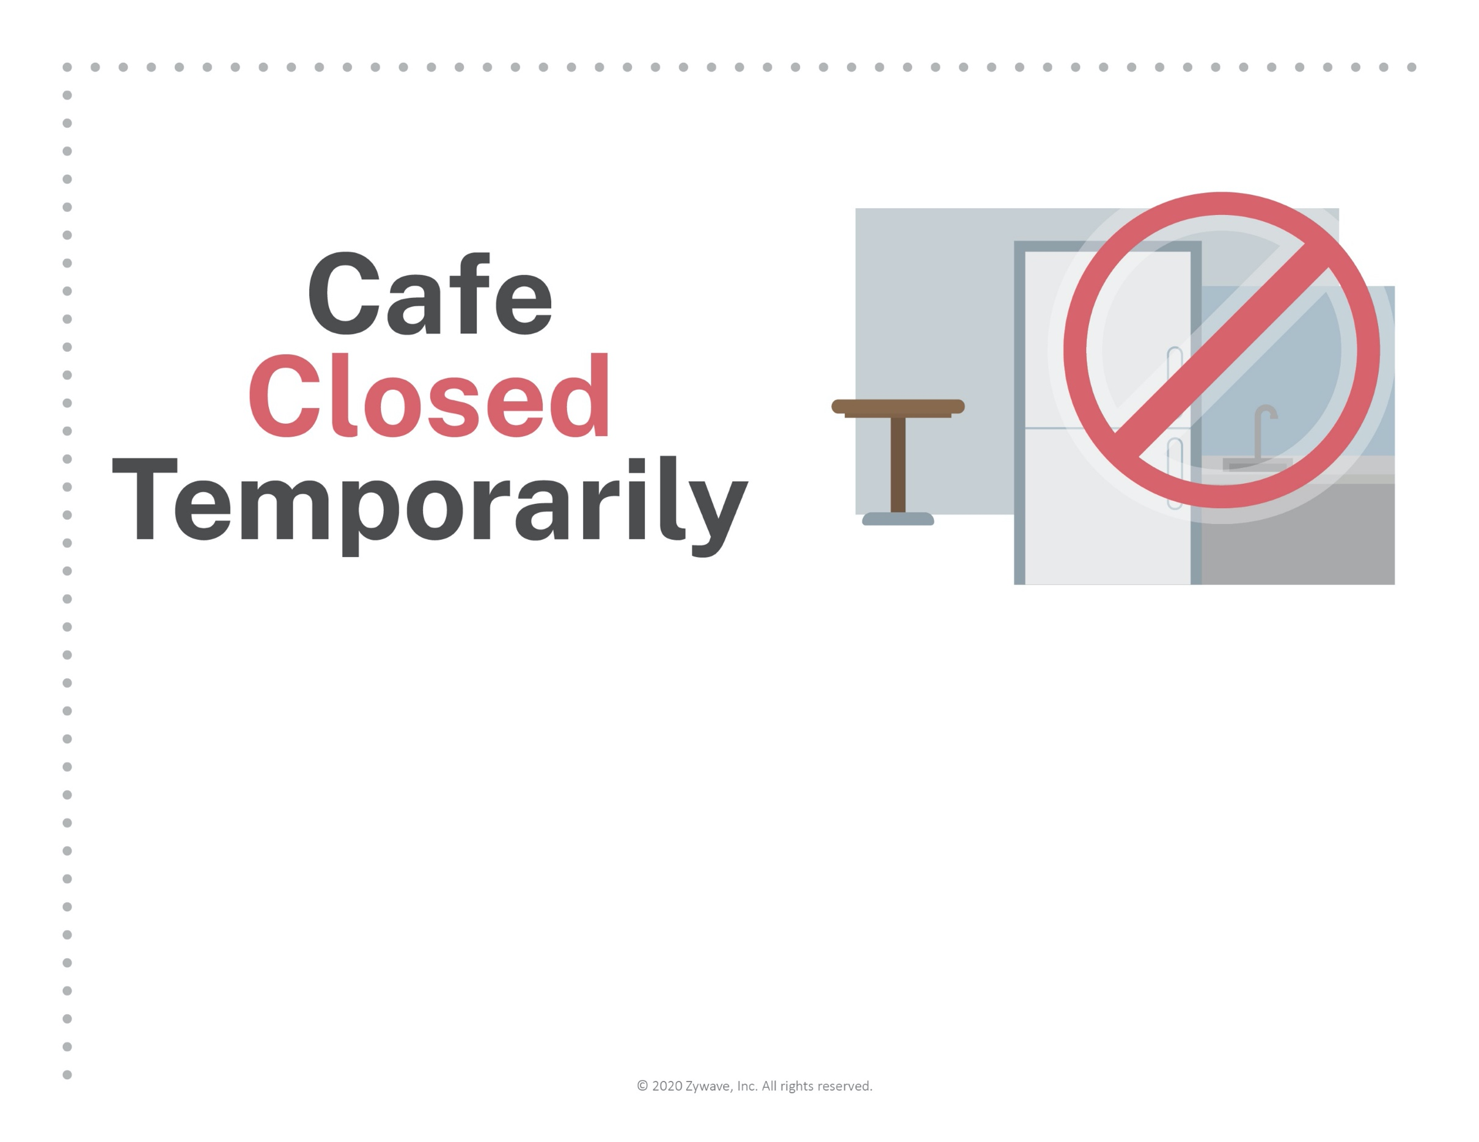
To ensure a safe and sanitary workplace,
[Company Name] has closed the cafe
until further notice.
We apologize for any convenience and
thank you for your flexibility.

